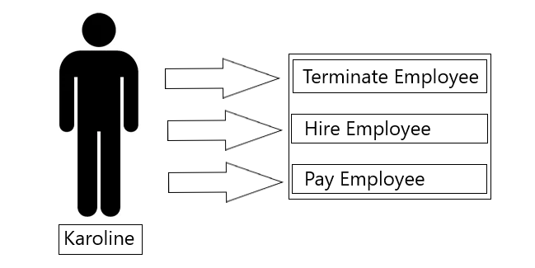

Employee Diagram

The above diagram depicts the interaction between Karoline and her employees. She can terminate an employee, hire an employee or pay an employee.